# GitFlow Examples

These examples are using the default configuration with GitVersion. Which is [continuous deployment](https://gitversion.readthedocs.io/en/latest/reference/continuous-deployment/) mode for develop and [continuous delivery](https://gitversion.readthedocs.io/en/latest/reference/continuous-delivery/) mode for all other branches.

This default configuration allows you to publish CI builds from develop to a CI MyGet feed, or another CI feed. Then all other branches are manually released then tagged. Read more about this at [version increments](https://gitversion.readthedocs.io/en/latest/more-info/version-increments/).

## Feature Branches

Feature branches will take the feature branch name and use that as the pre-release tag.

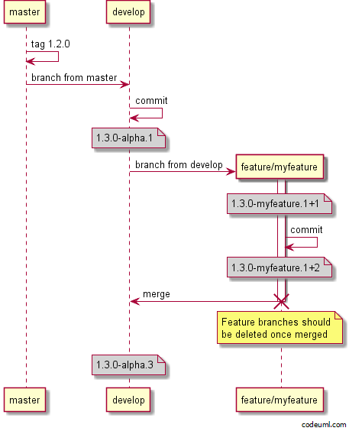

Notice after the feature branch is merged, the version on develop is 1.3.0-alpha.3. This is due to develop running in continuous deployment mode. If you configured develop to use continuous delivery the version would still be 1.3.0-alpha.1 and you would have to use release tags to increment the alpha.1.

You can see the difference on the feature branch itself, notice the version is the same before and after the commit on the feature branch? Only the metadata has changed. If you released the feature branch artifacts then tagged the commit, the following commit would increase to -beta.2.

## Pull Request

Because feature branches are most likely pushed to a fork, we are showing the pull request branch name which is created when you submit a pull request

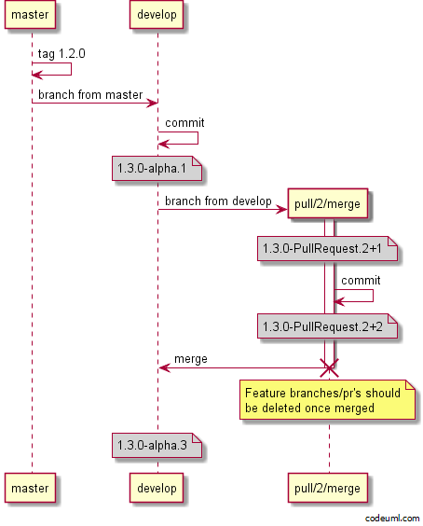

## Hotfix Branches

Hotfix branches are used when you need to do a patch release in GitFlow and are always created off master

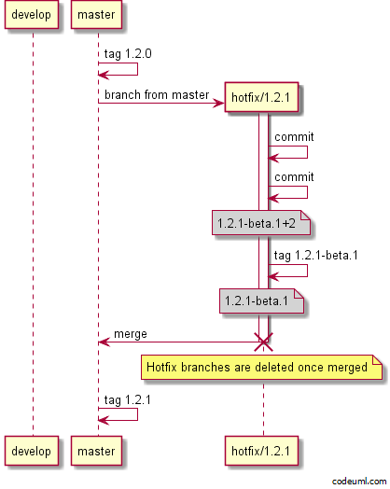

## Minor Release Branches

Release branches are used for both major and minor releases for stabilisation before a release. Release branches are taken off develop then merged to both develop and master. Finally master is tagged with the released version.

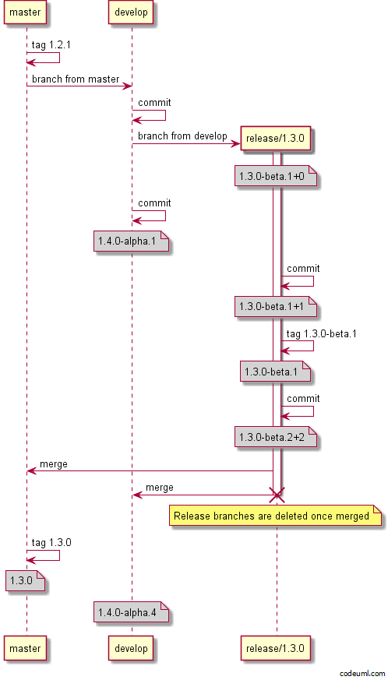

## Major Release Branches

Major releases are just like minor releases, the difference is you bump the major in the release branch name.

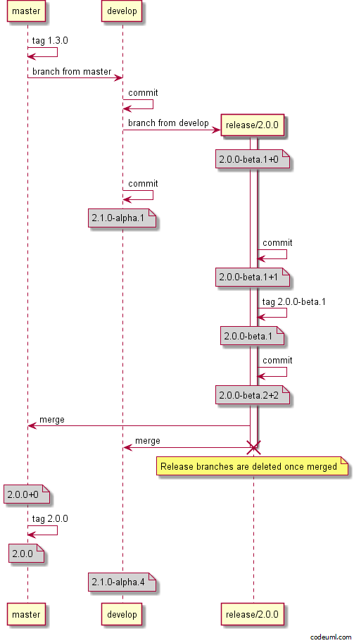

## Support Branches

Support branches are not really covered in GitFlow, but are essential if you need to maintain multiple major versions at the same time. You could use support branches for supporting minor releases as well. If you are just supporting the majors, then name your branch support/<major>.x (i.e support/1.x), to support minors use support/<major>.<minor>.x or support/<major>.<minor>.0. (i.e support/1.3.x or support/1.3.0)

### Hotfix

Depending on what you name your support branch, you may or may not need a hotfix branch. Naming it support/1.x will automatically bump the patch, if you name it support/1.3.0 then the version in branch name rule will kick in and the patch will not automatically bump, meaning you have to use hotfix branches. 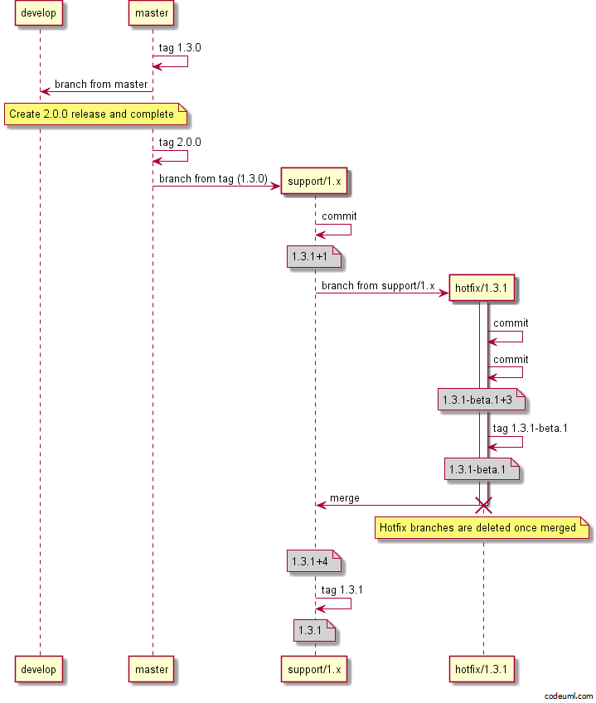

### Minor Release

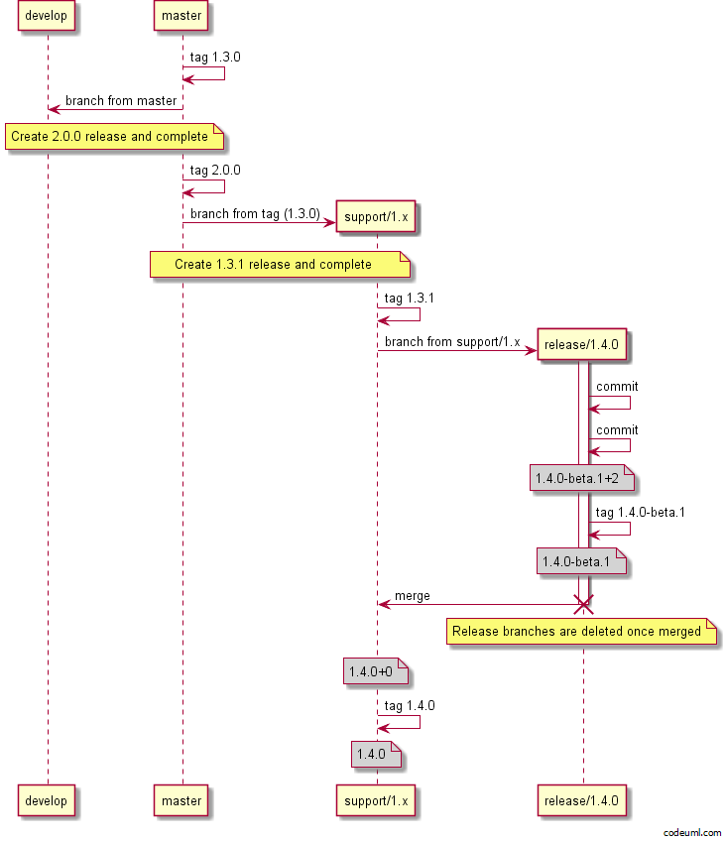

# GitHubFlow Examples

## Feature branch

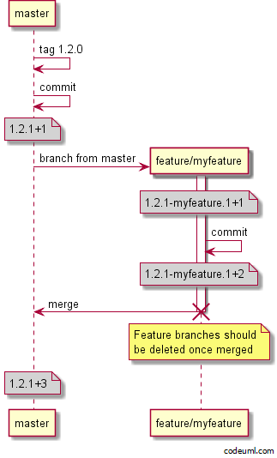

## Pull requests

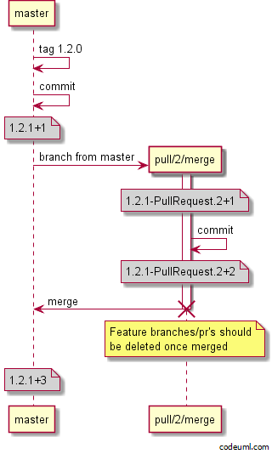

## Release branch

Release branches can be used in GitHubFlow as well as GitFlow. Sometimes you want to start on a large feature which may take a while to stabilise so you want to keep it off master. In these scenarios you can either create a long lived feature branch (if you do not know the version number this large feature will go into, and it's non-breaking) otherwise you can create a release branch for the next major version. You can then submit pull requests to the long lived feature branch or the release branch.

